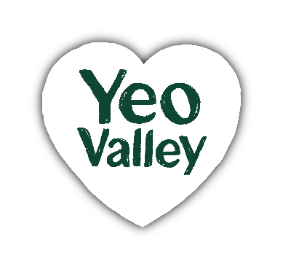  The finer details  Which site am I based at?  Yeo Valley HQ  Which teams am a part of?  YVP Marketing Team  Who do I report to?  Marketing Operations Manager  Who do I look after?  n/a  Team size?  n/a  Responsibility for a budget?  n/a  Experience & Qualities  Essential:  - Qualifications linked to business, or project management.  - A genuine interest in marketing, food & sustainability.  - Strong ability in planning, organising, with attention to detail.  - Highly numerate, good presentation skills and a confident communicator both verbally and in written form  - Strong analytical skills to interpret data.  - A self-starter that has energy, drive and a desire to learn.  - A strong collaborator with good communication skills. |     YVO Marketing Project Co-Ordinator  Job description  The purpose of your role  Collaborating with teams across Yeo Valley, this is a hands-on coordination role offering the opportunity to build strong project management skills while supporting meaningful marketing activity.  This role will influence through clarity, collaboration, and consistency. Helping teams align on shared plans, make timely decisions, and adopt efficient delivery.  You will help bring our brands to life with consistency and distinctiveness, inspiring co-owners, and external partners to understand and champion YVO’s purpose and ambitions.  The role will help embed a stronger project management mindset across the marketing team by supporting consistent ways of working, encouraging clearer ownership, and supporting teams to plan, prioritise and deliver activity with greater confidence and accountability.  Your responsibilities:  - Artwork coordination: Co-ordinate the artwork approval process through Flowmation, ensuring assets move efficiently through each review stage. Working collaboratively across teams to maintain timelines, track costs and ensure quality and compliance.  - Project management: Act as a positive advocate for structured project management, helping our co-owners adopt consistent tools, processes and behaviours that improve visibility, accountability, and delivery across marketing activities.  - Brand growth projects: Coordinate projects that support brand growth and sustainability credentials, from kick-off through to delivery, ensuring the right people, processes and timelines are in place.  - Reporting and analysis: Support Marketing Ops manager to support on project and gate process data and tracking. Prepare reports and provide insights as required.  - Ways of working and continuous improvement: Work collaboratively across the Yeo Valley Organic, Tideford and Ubley brand teams to share learnings, identify synergies and support continuous improvement for project planning and delivery.  - Purpose-led delivery: Understand and embrace our company purpose, ensuring your work helps to Nurture & Nourish People & Planet.  What good looks like for this role  Project Coordination  Uses project management tools and routines to create visibility, improve accountability and encourage more consistent delivery across the team.  Business expertise  Understands key business drivers and the impact of the work within this role and how it contributes to brand growth.  Leadership  Ability to bring together cross functional teams to deliver artwork to launch. Provides informal guidance to new team members to help them understand the artwork and gate process and their role within it.  Problem solving  Ability to solve problems in straight forward situations. Provides possible solutions and recommendations using precedents and personal judgement.  Measurement and Evaluation  Identifies appropriate metrics, ensures marketing activity supports agreed goals and objectives, and highlights opportunities for optimisation and improvement.

HR use

Date of last review: Job reference no: Job level:
Job family:

